**GOLARS Project document**

**Project Scope Description:**

GOLARS is the user friendly web based application, which allows the users to import the downloaded documents of US Govt public site and storing on Golars database.

The application automates the process of creating the multiple folder and import multiple documents & files from the public website of US Govt and storing on company's Data Base for future references to track/refer the documents/policy (PDF/WORD/images).

**Project Requirements:**

**User login/logout page**

[**http://golars360.com/golarsUI/#/login**](http://golars360.com/golarsUI/%23/login)

Login page displays GOLARS logo on top of login section and right side panel would display company's content details.

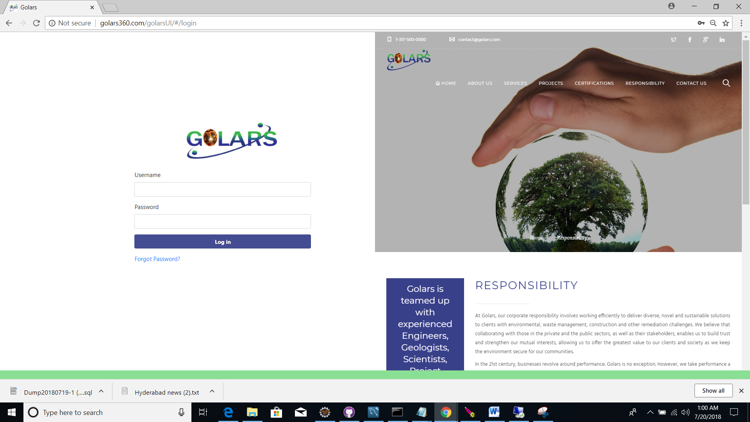

* Existing users would allow to login to the site.’
* If user forgot the password, it has a facility to reset the password by using “[Forgot Password?](http://golars360.com/golarsUI/)” link.
* Right side panel’s company details page is user configurable, it can be updated from configuration

section ”Login content”.

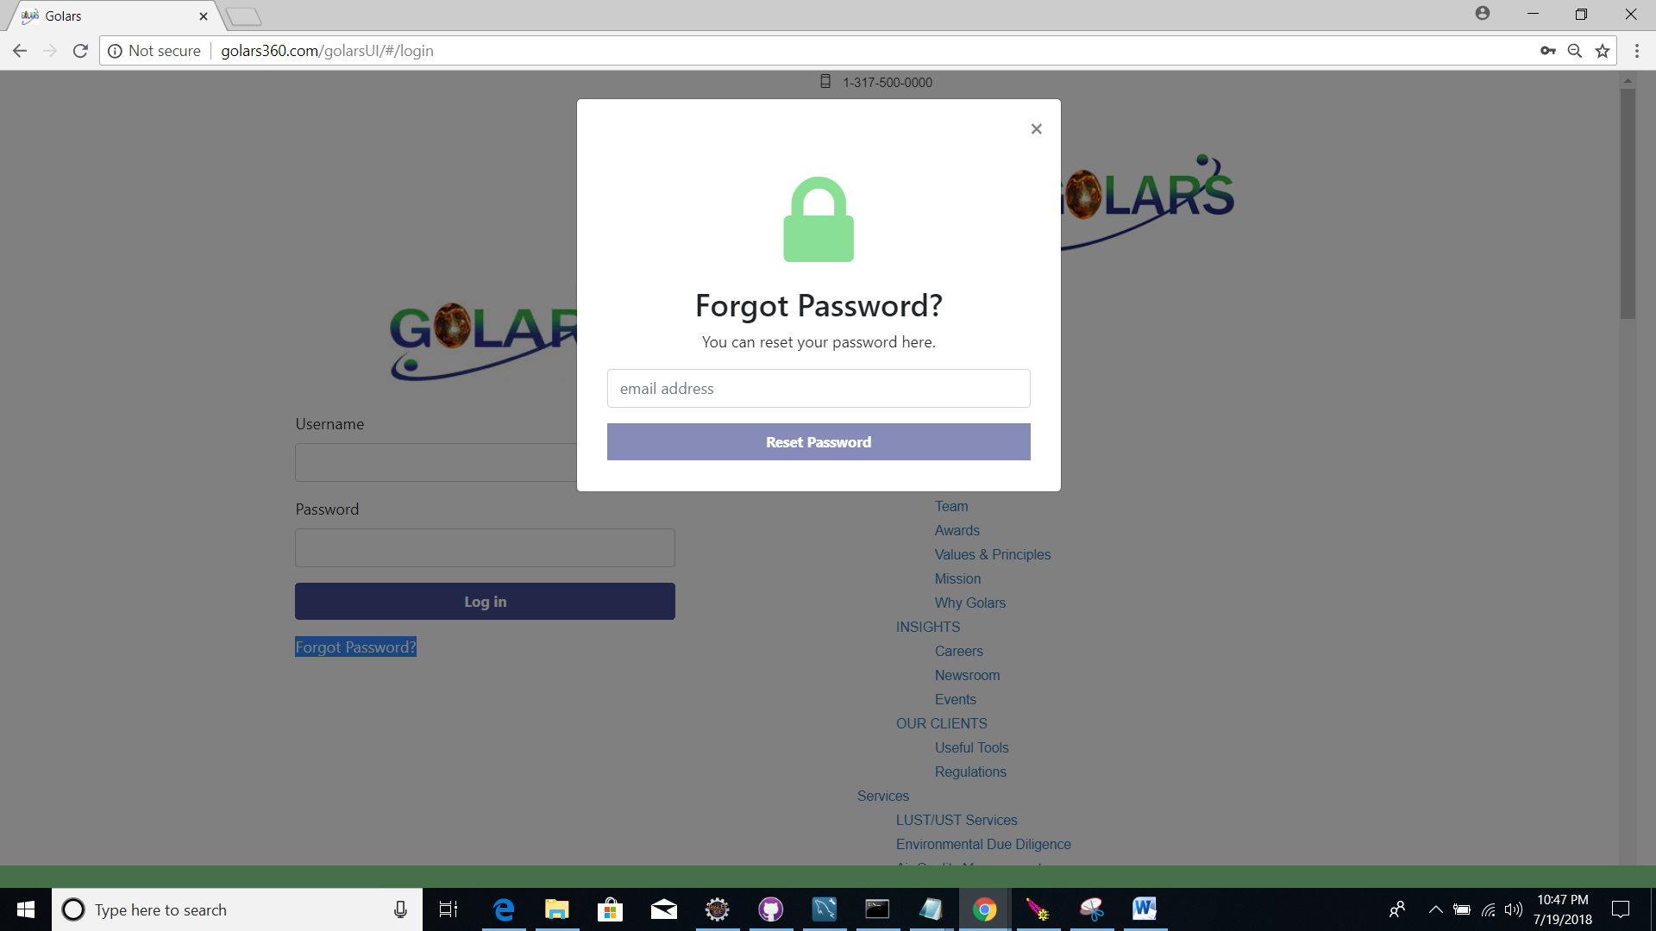

* Once click on “Forgot Password” link, it will open popup page to enter registered email-Id and click on submit

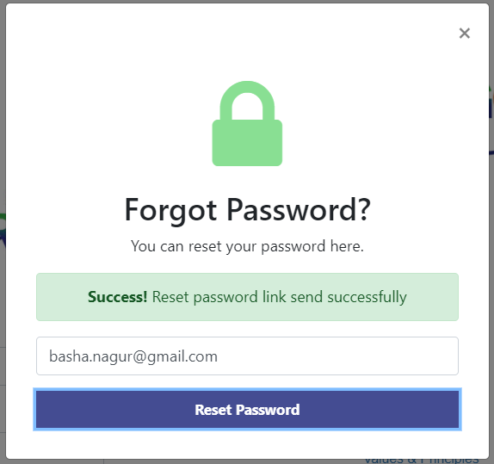

* User will get the email from golars to reset the password link.

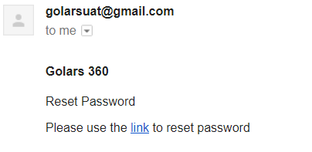

* Link will navigate to Reset Password screen and user can reset the new password.

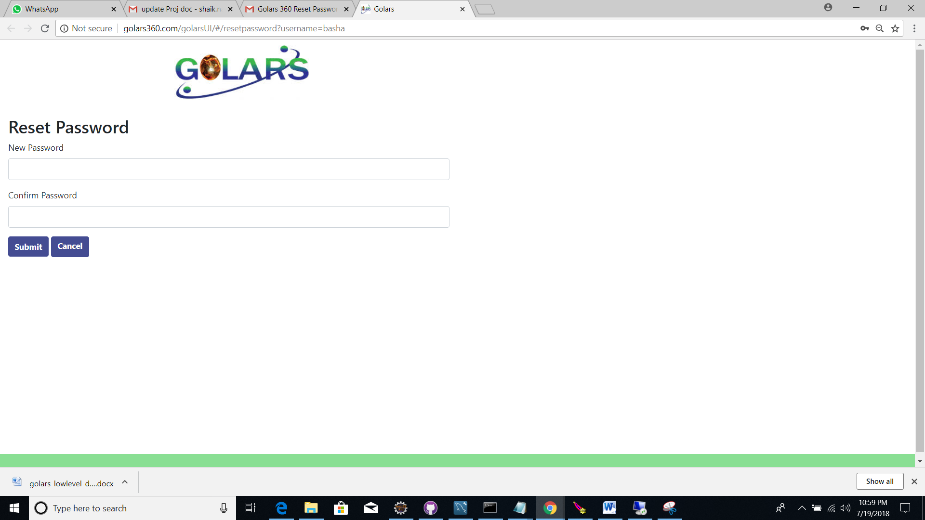

After reset, user will get changed password details to registered email

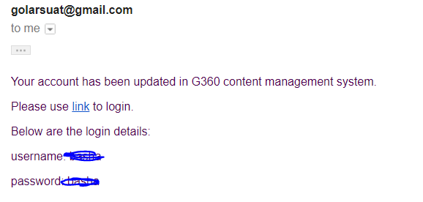

* If user enters invalid email-id, it will throw an error message.

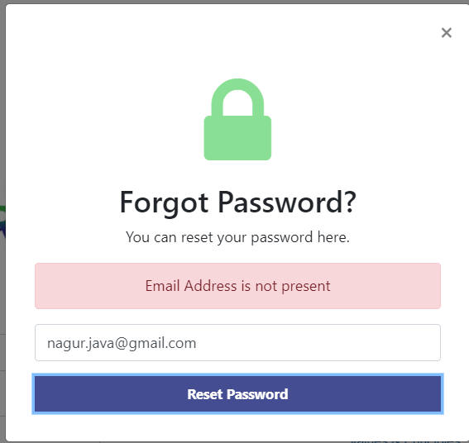

**GOLARS home page**

Home page divided into 3 sections (20%, 50%, 30%) and footer with copyrights message

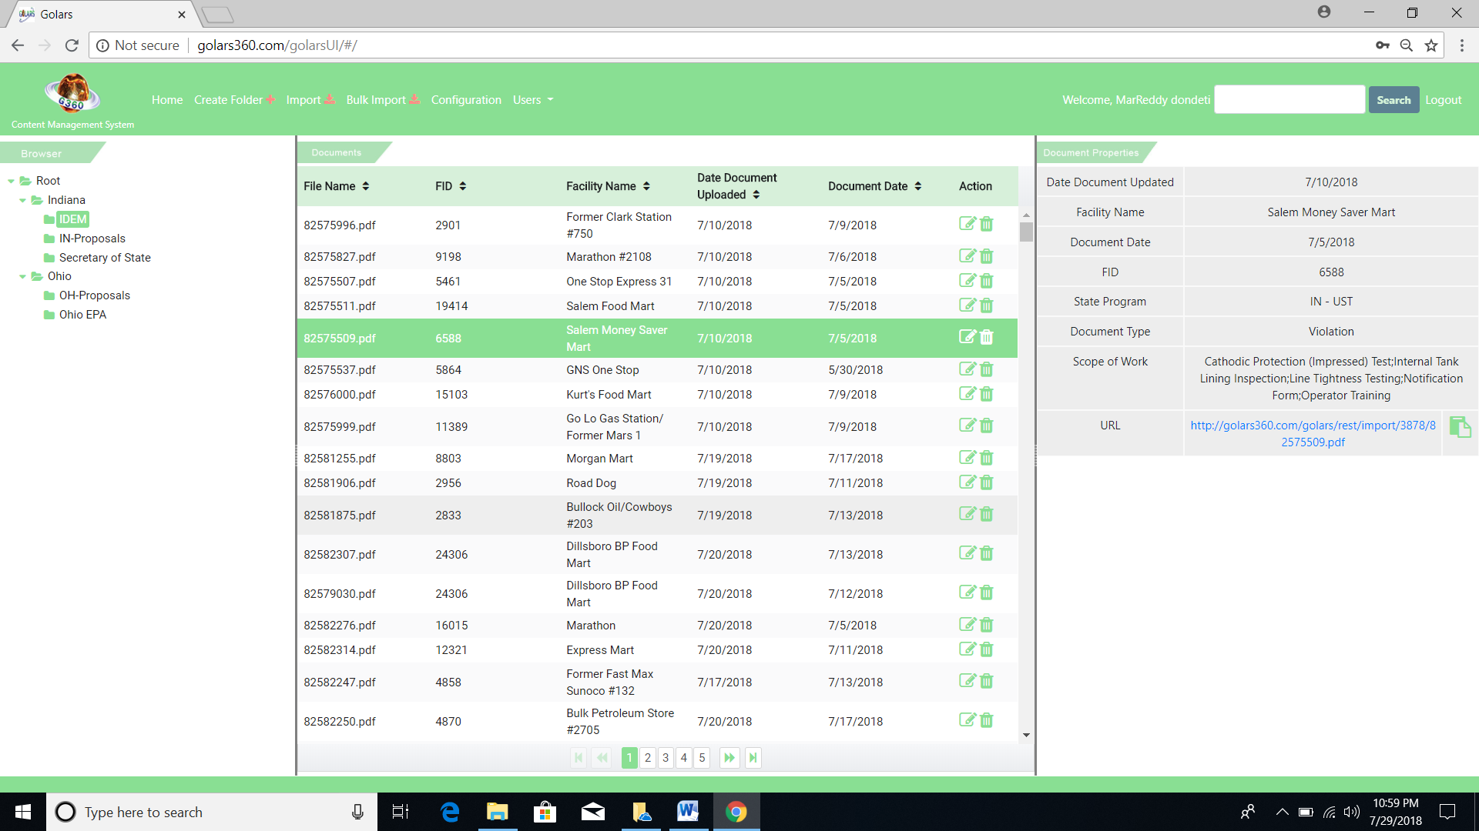

Menu bar having GOLARS logo with static content caption “Content Management System” below the logo from left upper corner, it follows 5 menu links.

* Home
* Create Folder
* Import
* Bulk Imports
* Configuration
* Users
* It follows the Welcome, by successfully logged in user name,
* Search functionality will allow the user to search the documents/files from the respective selected folders
* Logout will navigate the user to home page.

**Left panel - Browser section**

* Root folder doesn't contain any folders by default. Admin user need to create folder, folders are in tree structure.
* Root, folder, sub-folder and inside sub-folders. There won’t be any restriction on folder creation based on the user role. By default created folder would be on selected to import documents/file, new folders.
* Folder visibility would be defined by admin user; admin user can view/delete all the folders and files.

**Middle panel – Document List section**

* Middle panel contains imported files and documents**.**
* When document/file selects on middle panel, respective documents/fileproperties will display on right side panel.

Create folder

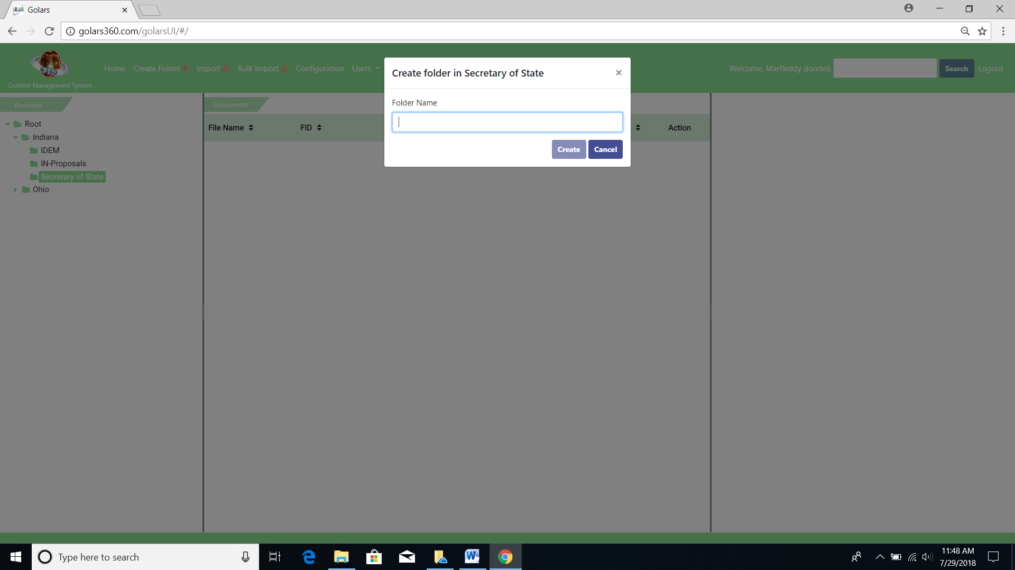

Delete folder

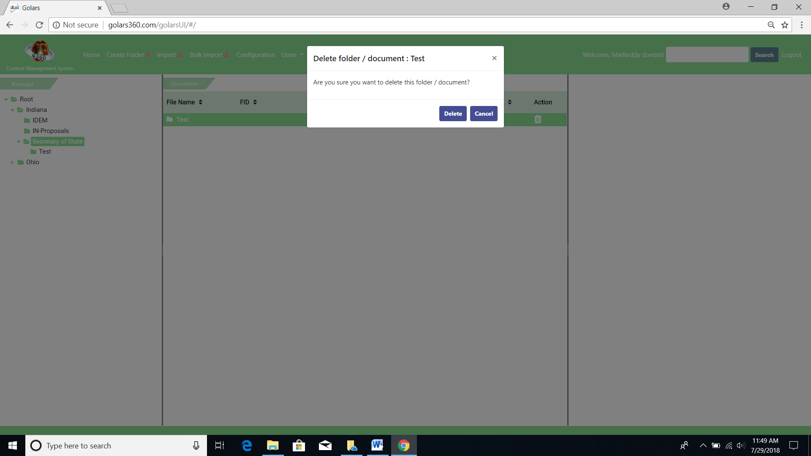

**Right panel – File properties section**

* Selected documents properties will display on properties section.
* Document link icon (url) would be available on properties section to users to copy/paste that **url** on bowser and review/refer the respective document or directly open the lint on the same page (browser).

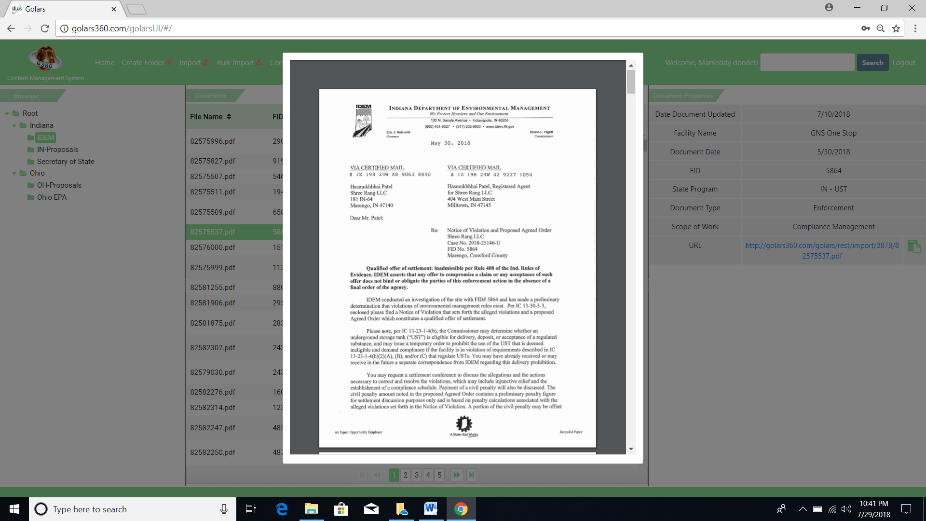

**User registration page:**

Current system has two roles

* Admin User
* NonAdmin User

**Admin user:**

* Admin is a root user, he/she will get initial password and it will navigate to mandatory reset password page when he/she get the initial password.
* Same functionality (initial password reset) is applicable for NonAdmin users when they get initial access.
* Admin user can view Home, Create Folder, Import, Configuration, Users on the menu section.
* Admin can have an option to **Add**, **Edit, and Delete** the users.

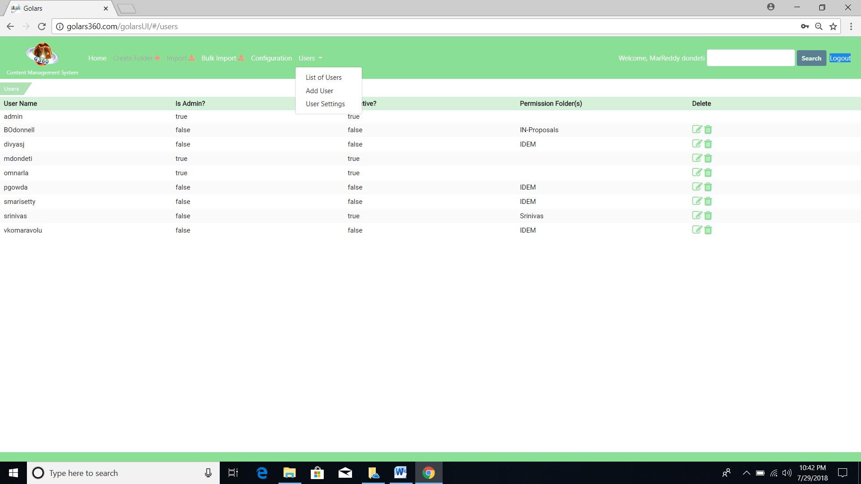

Admin user can provide the access to select the Document List Table Columns for Admin/NonAdmin and can update, based on the selection user can see the details of the documents on Document list section.

**Users Settings**

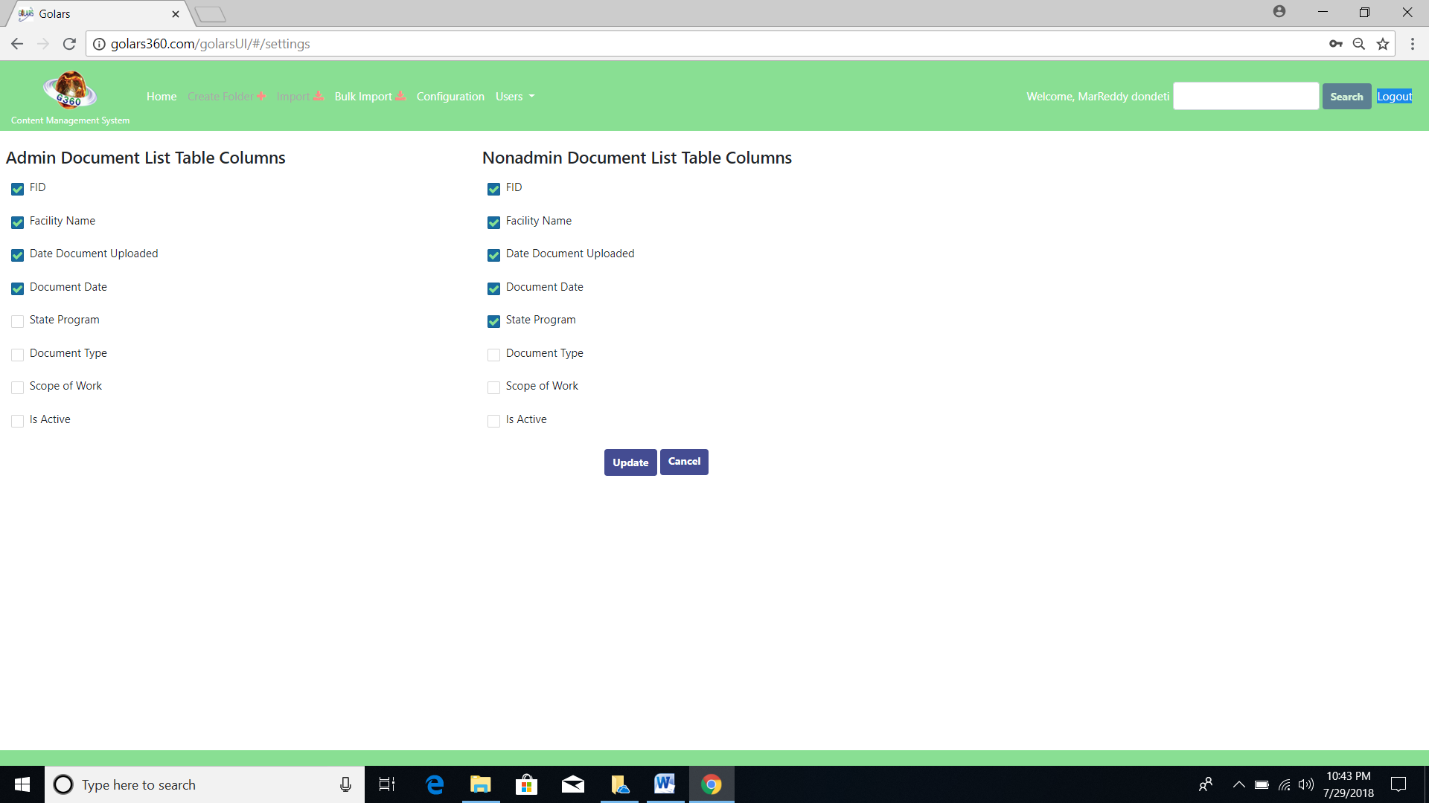

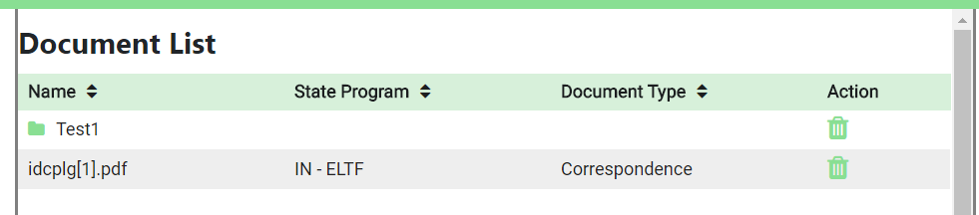

**Document List sorting**

* + Document list can be SORT by properties selected on “User Settings” from the Users menu.
  + List of documents are in deployed on page wise, user can go to the particular page by using pagination functionality.
  + Admin can select the display properties from User Settings.

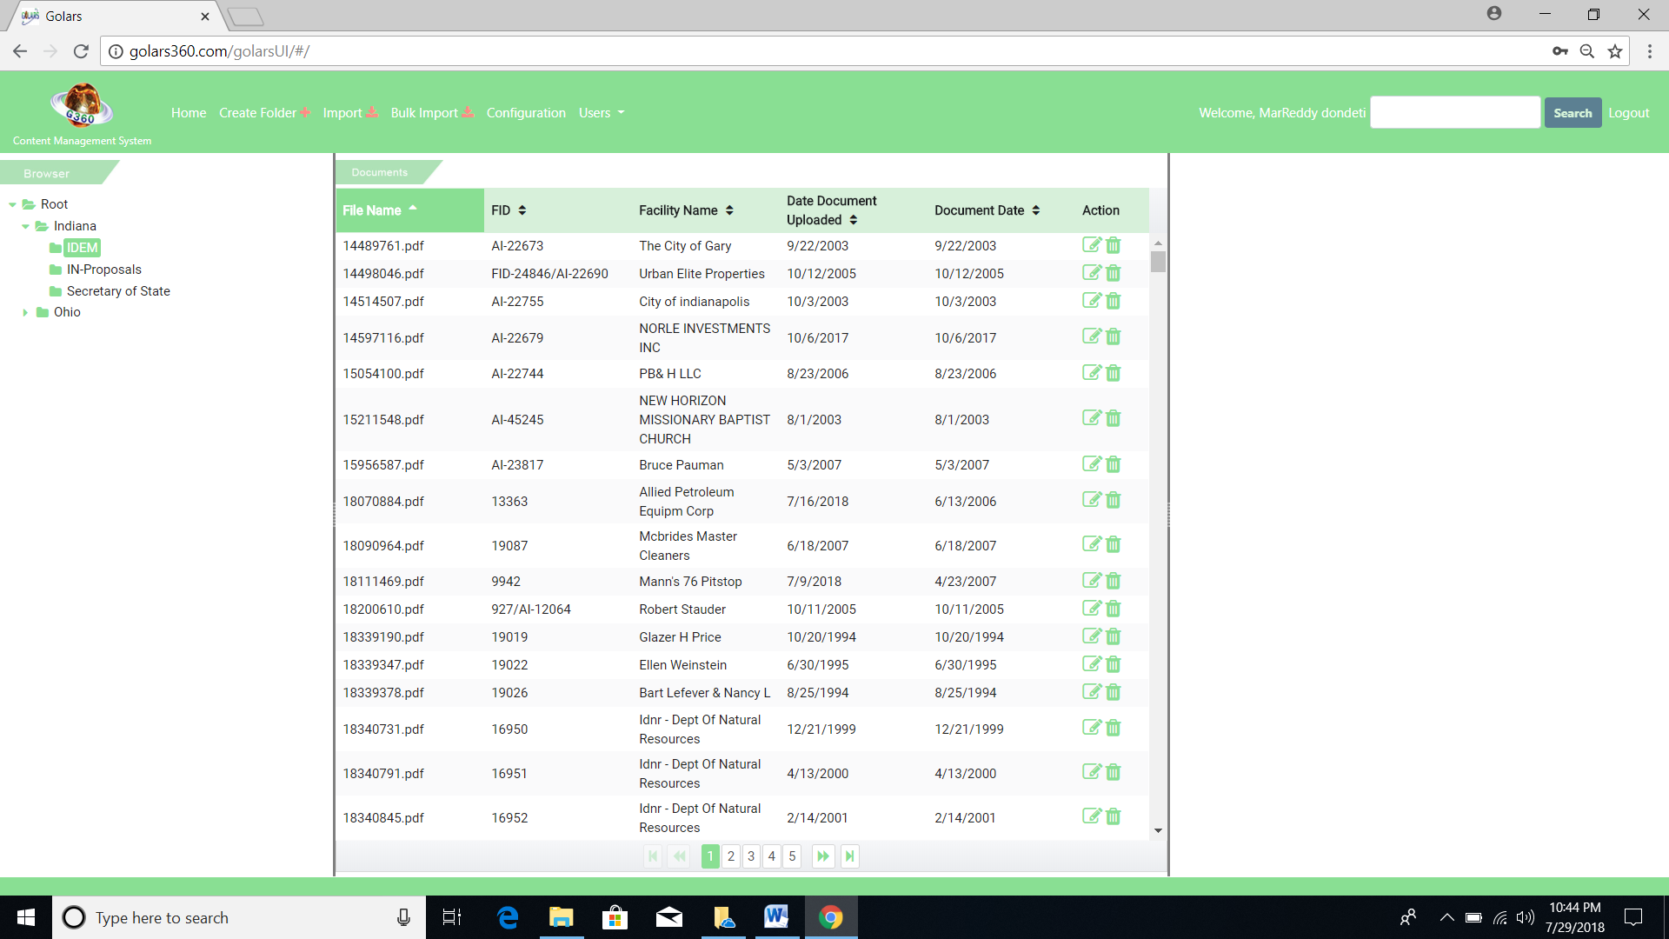

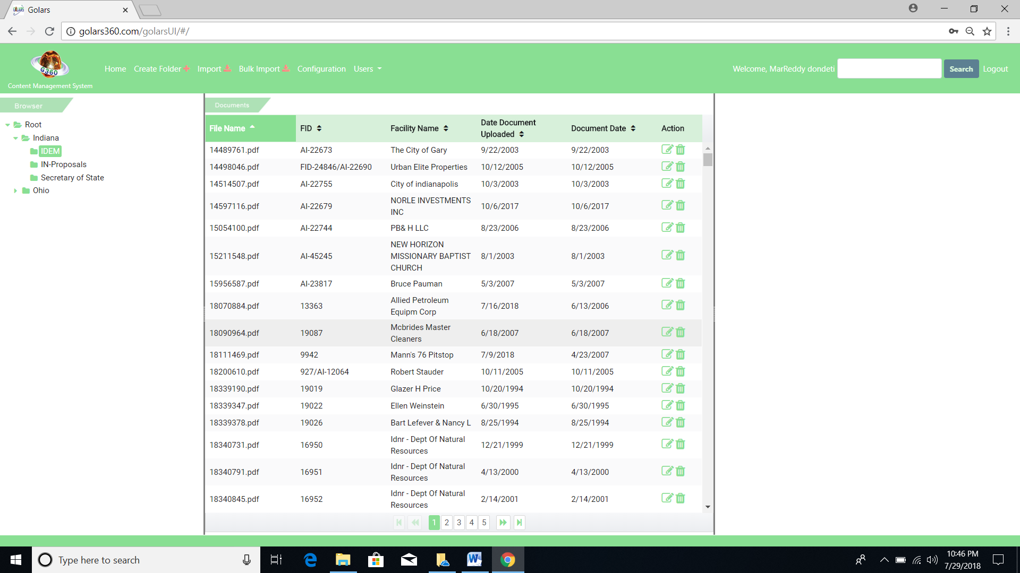

User Settings

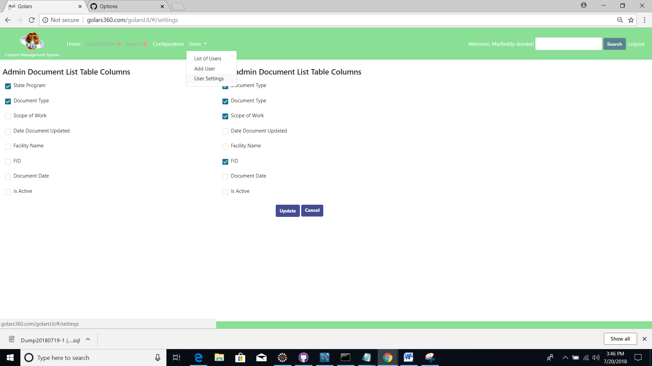

**User registration:**

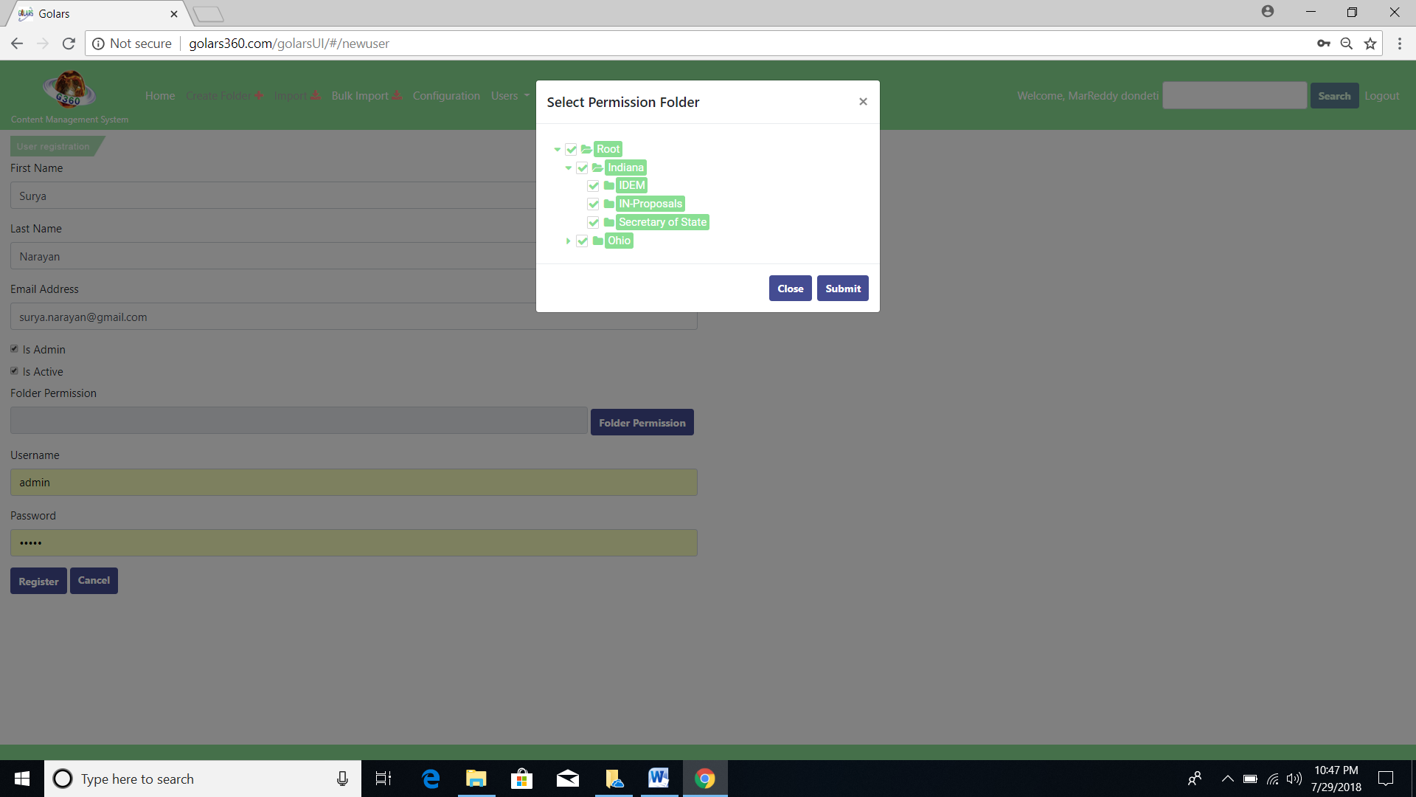

* All fields in the registration form are mandatory fields.
* Admin has privileged to give admin/non-admin, is Active user(by selecting checkbox).
* Folder visibility permission would be granted by Admin user by selecting the folder on popup window.
* Admin will grant folder permission (visibility) to the NonAdmin user while registering the new users.
* Username/Password should be minimum 5 chars, otherwise it won't allow registration.
* If user already exists, it would popup a message by saying “User Already Exists.”
* When Admin user changes the permission/user details of the user (NonAdmin to Admin vice-versa), they will get email confirmation of user detail changes.

**Configuration Menu**

**Login Content**

Admin has a provision to update the company content details on Login page by changing the URL on configuration menu.

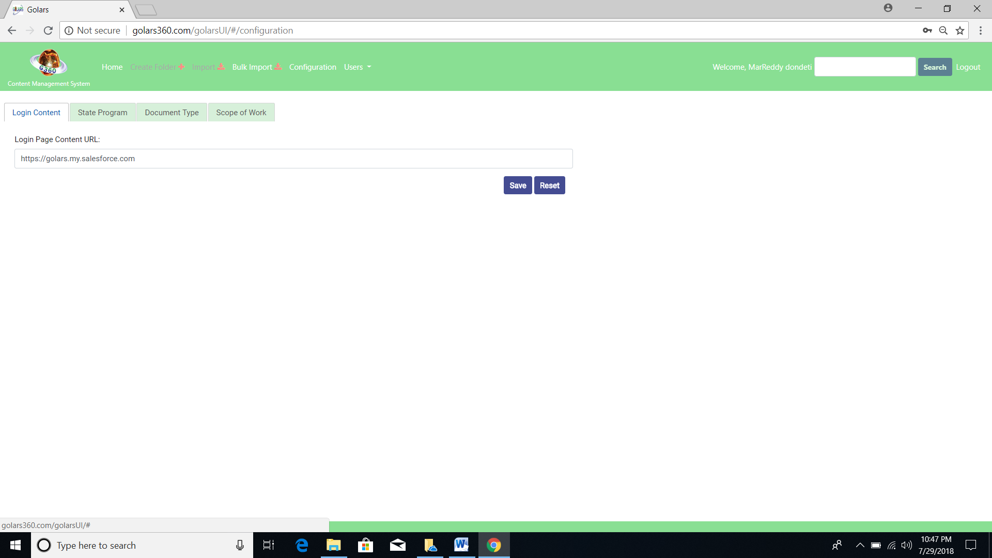

**State program**

* New State program can be added from “Add Picklist for State Program”
* Admin can delete/add state programs, saved state programs will display on the import section.
* By default added state program is in disable mode, user can enable/disable that.

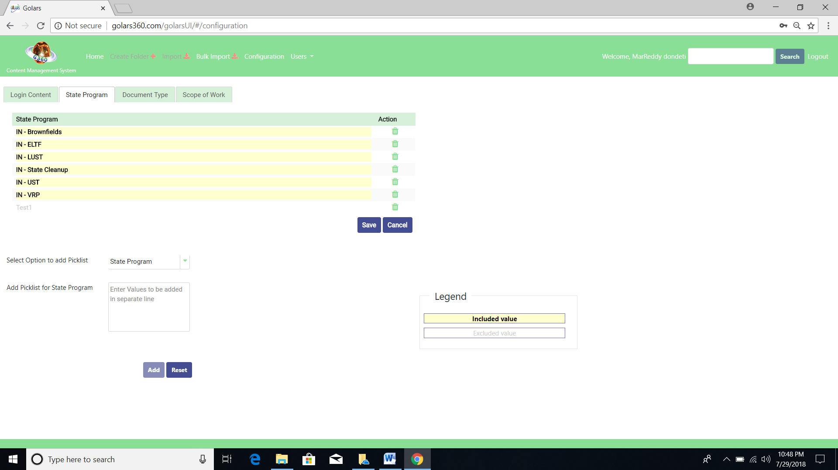

**Document Type**

* Document Type can be selected from the configuration page, from this list of documents, admin user can enable/disable on dropdown list of Import page.
* Admin user has a provision to enable/disable
* Pagination display on the bottom of the selection and user can navigate any page from there.
* Admin can add pick list of the document types

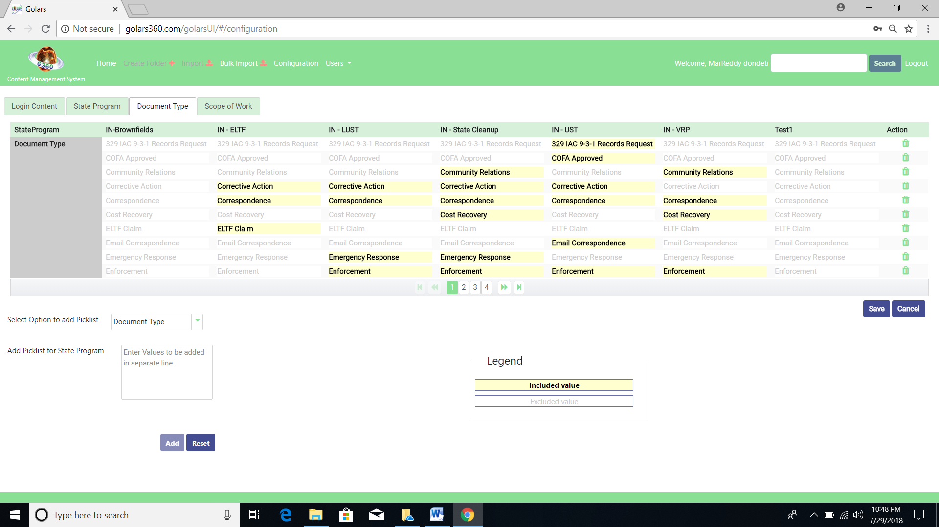

**Scope of work**

* Scope of work can be selected from the configuration page, from this list of scope of user, admin can select the checkbox on dropdown list of Import page.
* Admin user has a provision to enable/disable list
* Pagination display on the bottom of the selection and user can navigate any page from there.
* Admin can add pick list of the Scope of work

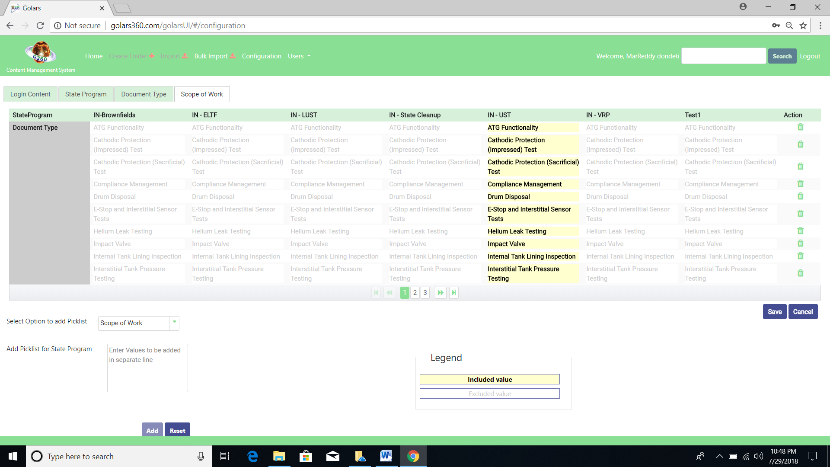

**NonAdmin users:**

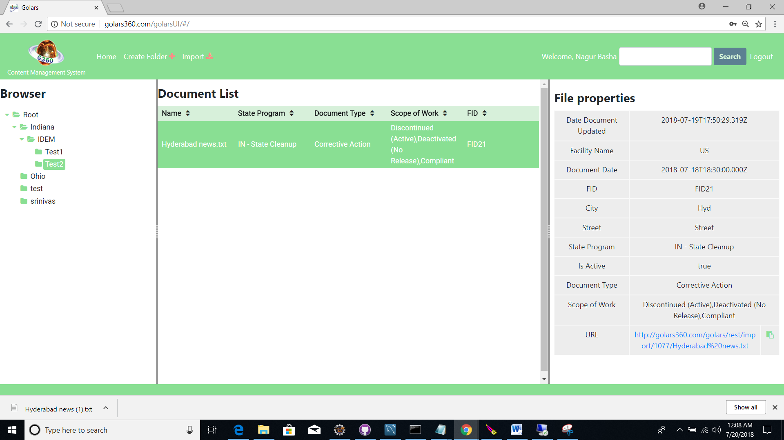

* Users can view Home, Create Folders, and Import menu only on the screen
* User can create folders/sub-folders & import documents/files.
* Users can’t have access to delete any folders/files.
* Remaining functionality would be common for all the users

**User registration validation page:**

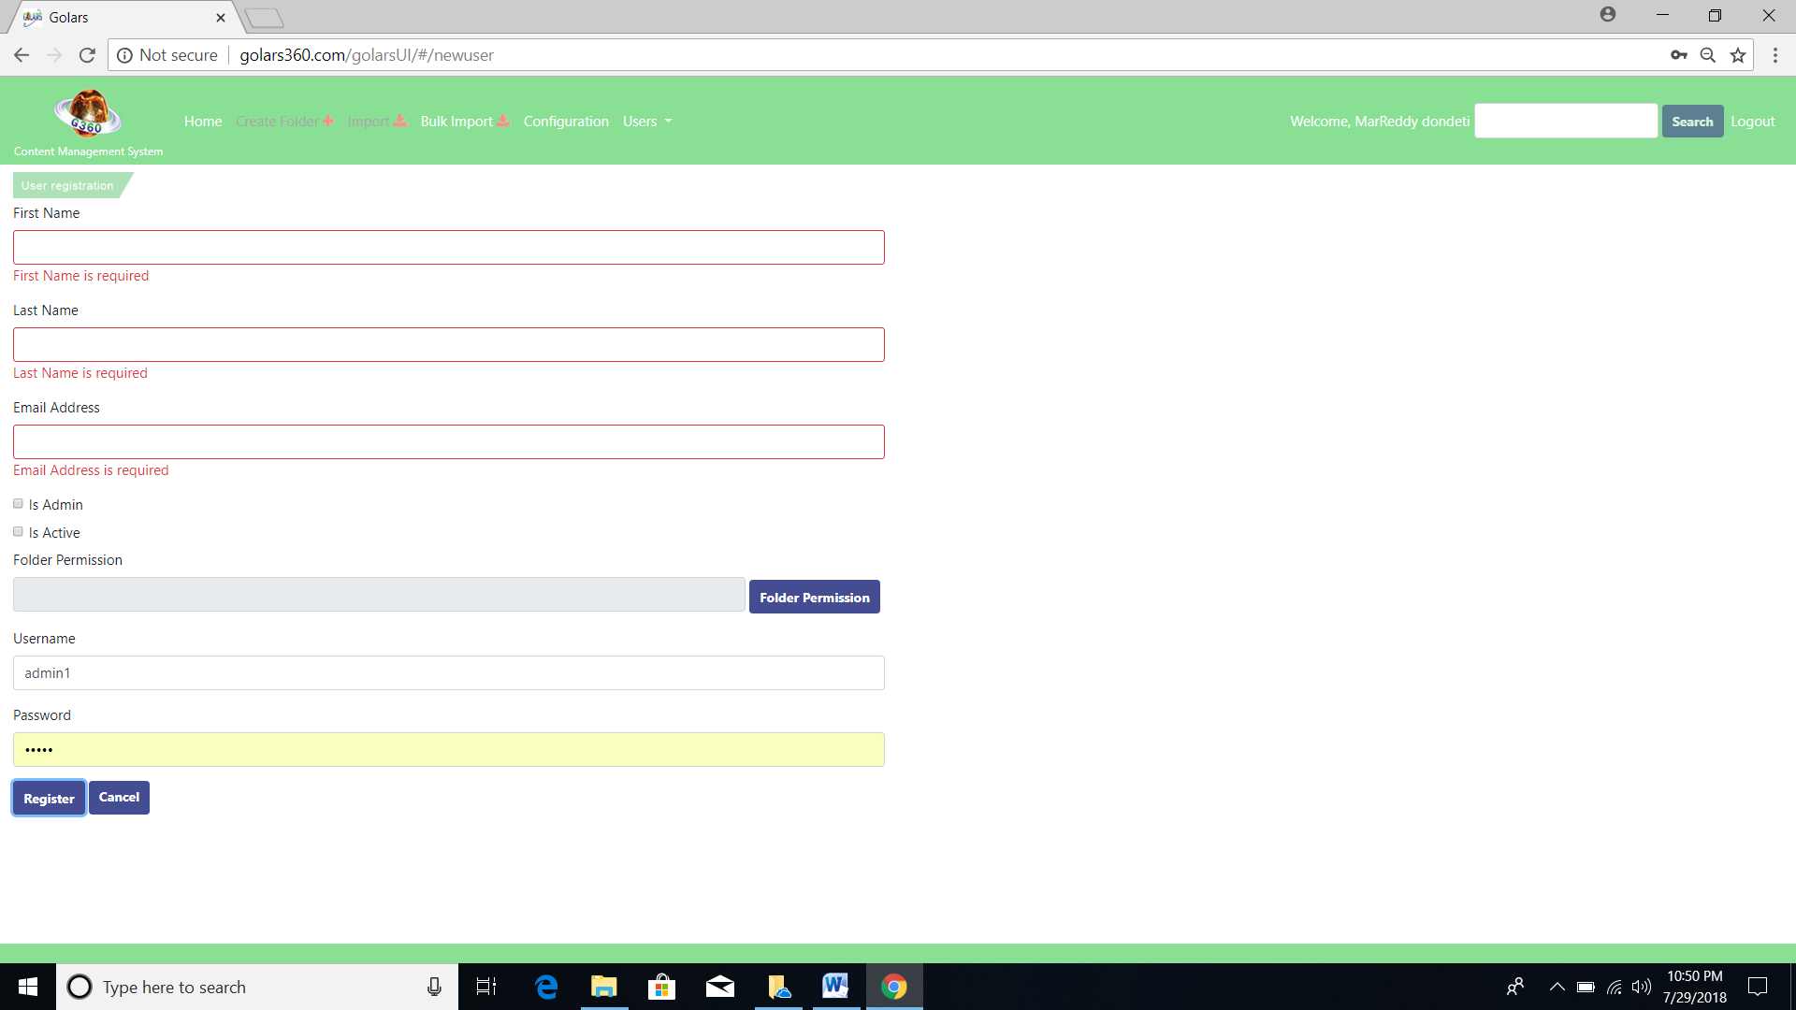

**Registration page:**



Registered data will be stored in the Data Base.

**Documents import page:**

When user clicks on the Import menu, dialog popup will display on middle of the page, to select import files and set properties to those files.

User can select multiple files from the system

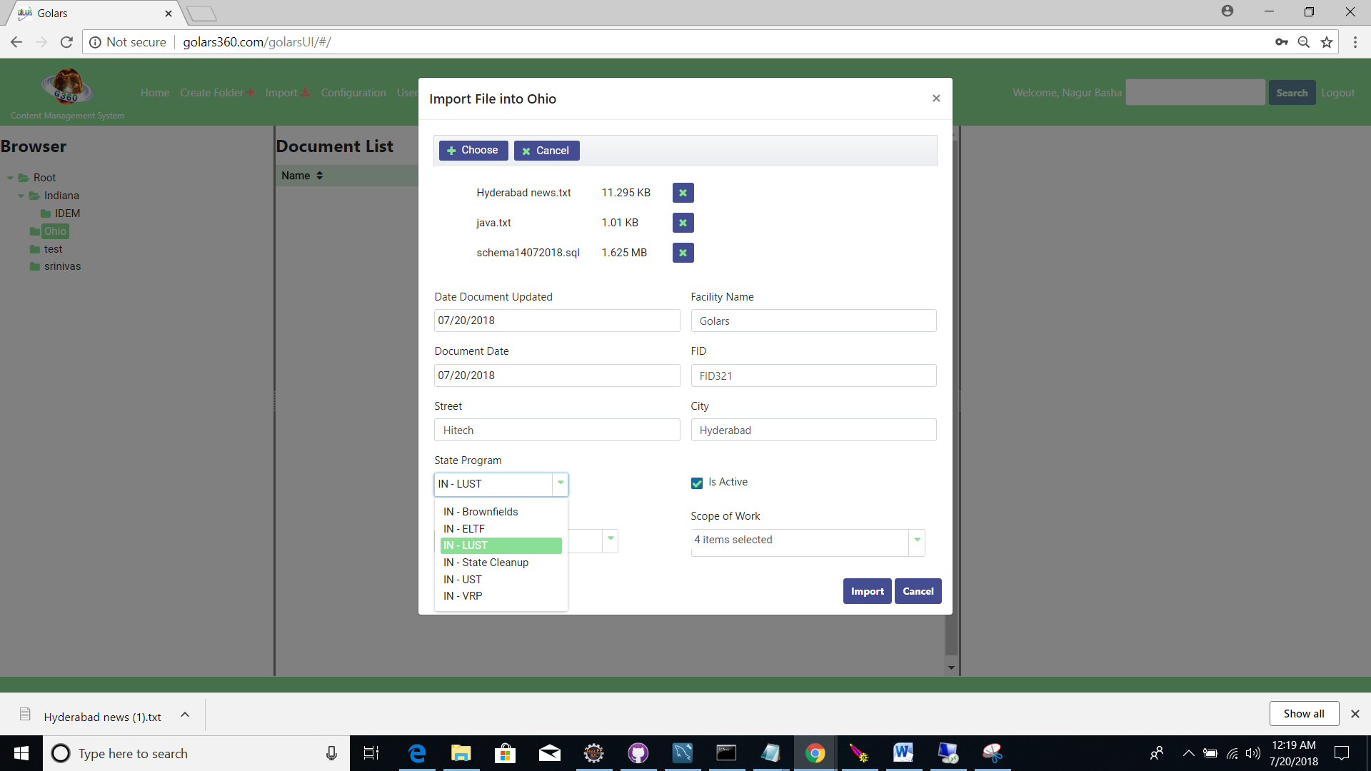

* Admin/Prevised users can able to creates any no of folders, sub-folders and files (PDF, Word docs) and save on folders.
* Users can import the multiple files on respective selected folder and set the properties on those files.
* Users have privileged to choose multiple files to import, and delete selected files.
* Date Document Updated default will take current date and Document date could be selected by users.
* Properties are not mandatory, users can put documents updated date, and imported date, select from date picker, Facility name, FID, etc...
* State Programs can select from drop-down menu, based on the **state program** selection corresponding **Document Type** dropdown list would display, based one Document Type selection **Scope Of work** checklist selection would display.
* **Scope of work** has multi selection option available; users can select available options and set as property.
* Users can delete/view multiple folders/files based on their roles/permissions.
* Users can get the respective files (PDF/WORD documents) URL, to navigate on web browsers without any restrictions.
* Users can copy/paste the **url** on bowser to review/refer the respective document or can open the document on the browser to refer when user click on the url link from the properties section.

**Scope of work**

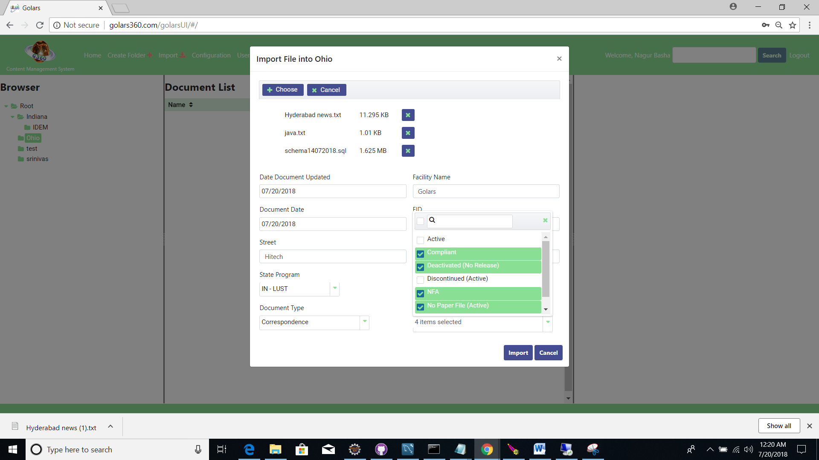

**Date picker screen:**

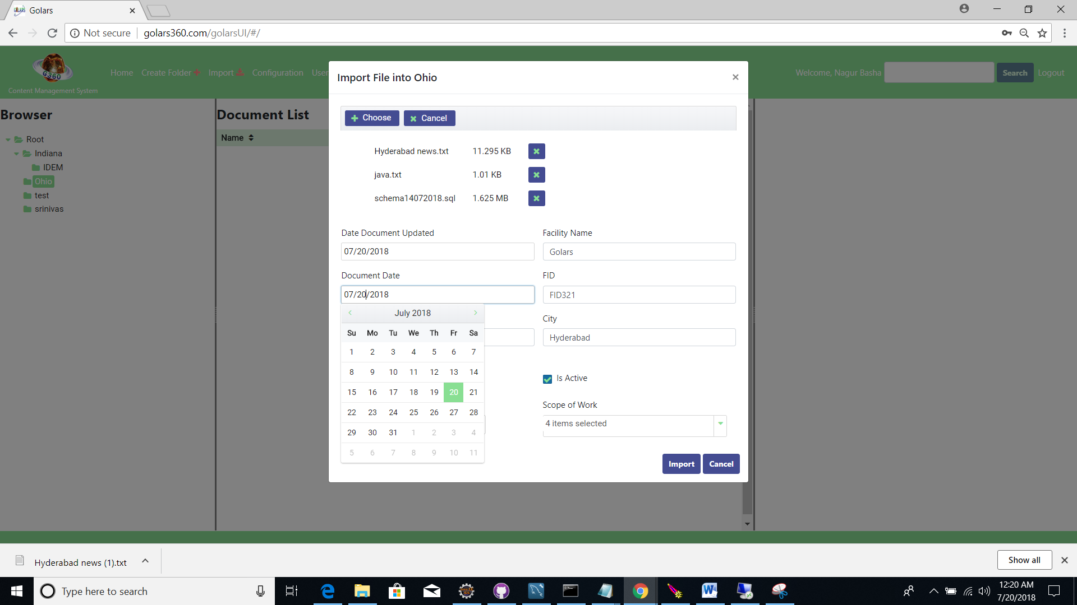

If no document selected for import, popup page display message "**Please select at least one file to Import**"

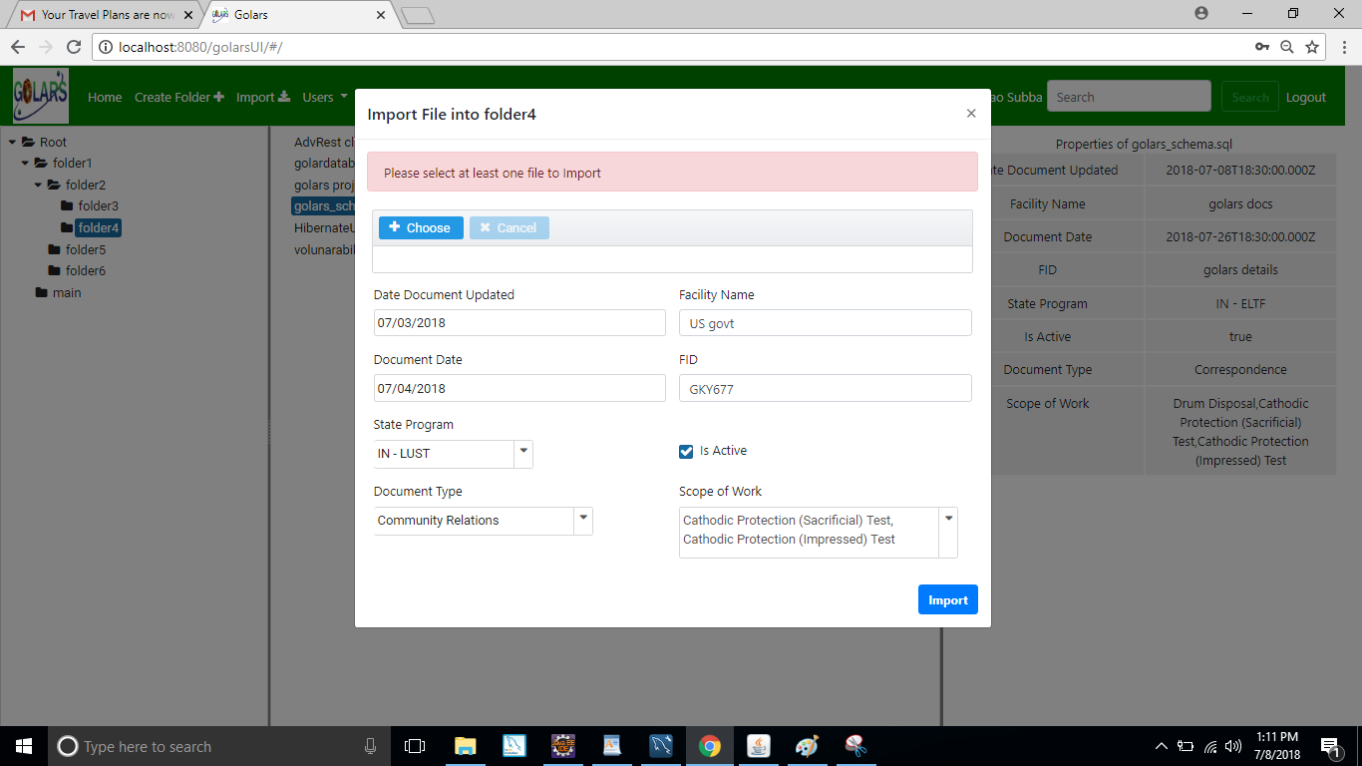

After import popup will display "**Success! File(s) Imported Successfully!!**" and clear off all selected details from the popup page

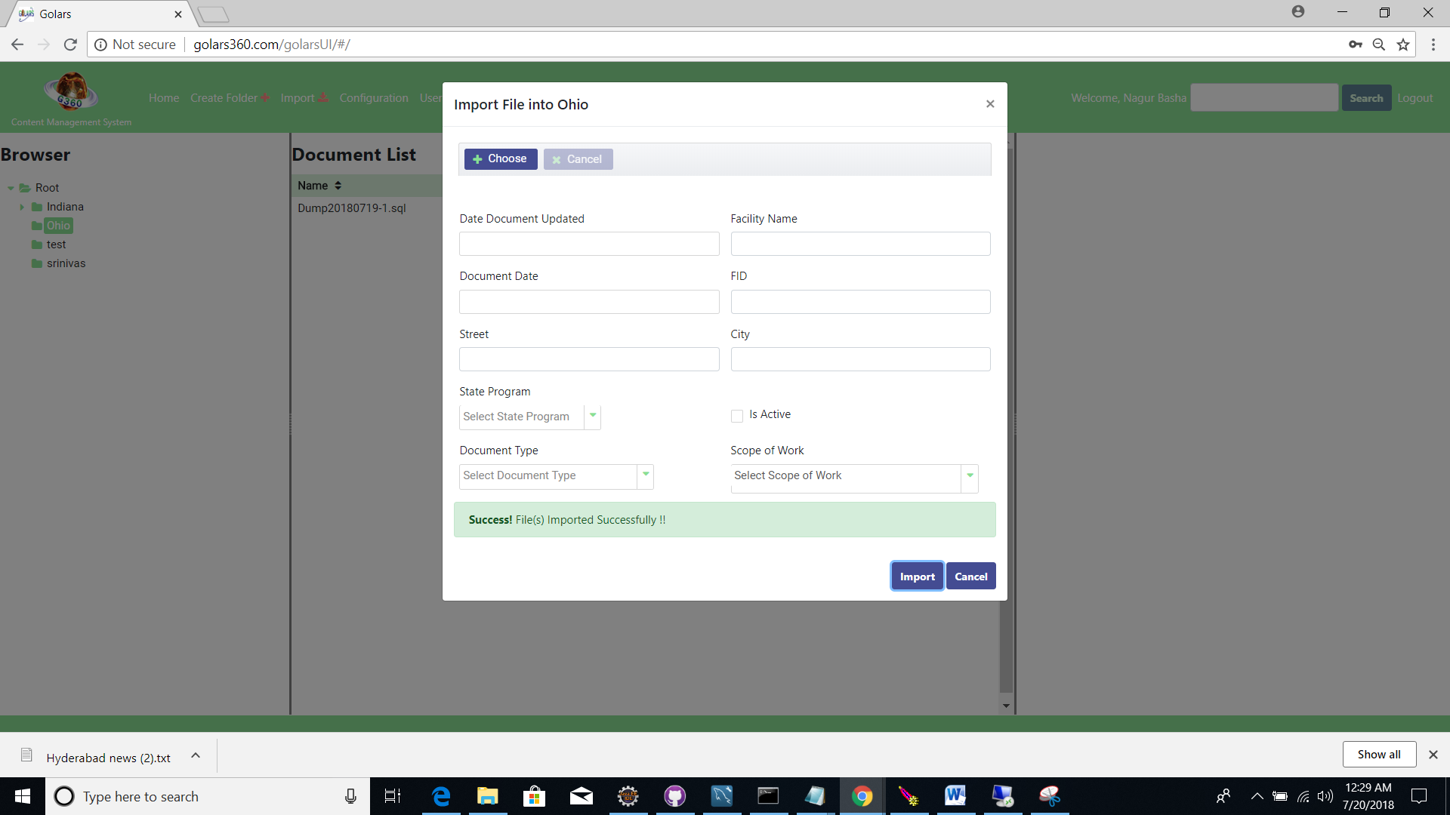

If user tried to import same files/documents a message will display on popup window

**"Document(s) already exists**". Users can delete and select deferent files/documents.

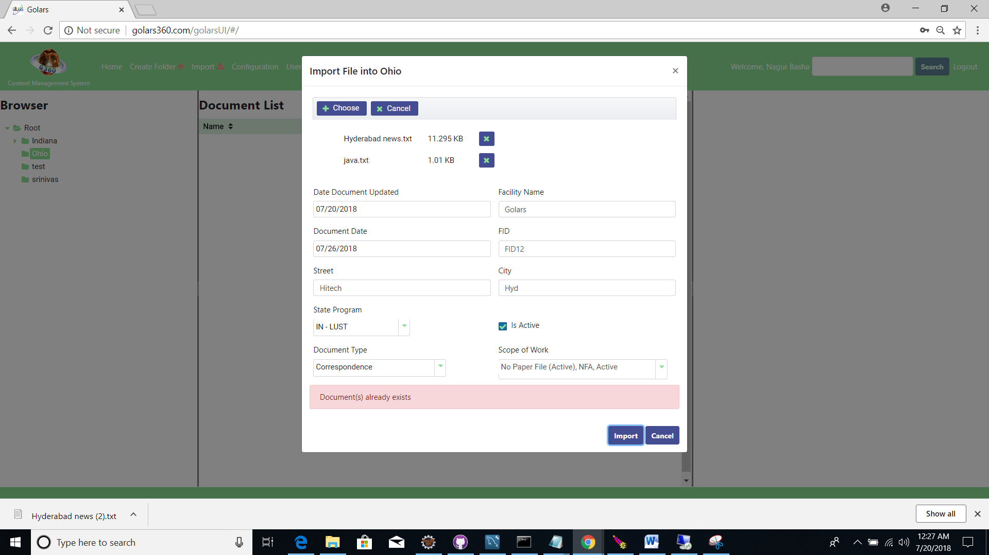

Download PDF/DOCs from browser link (ex: <http://gahp.net/wp-content/uploads/2017/09/sample.pdf>)

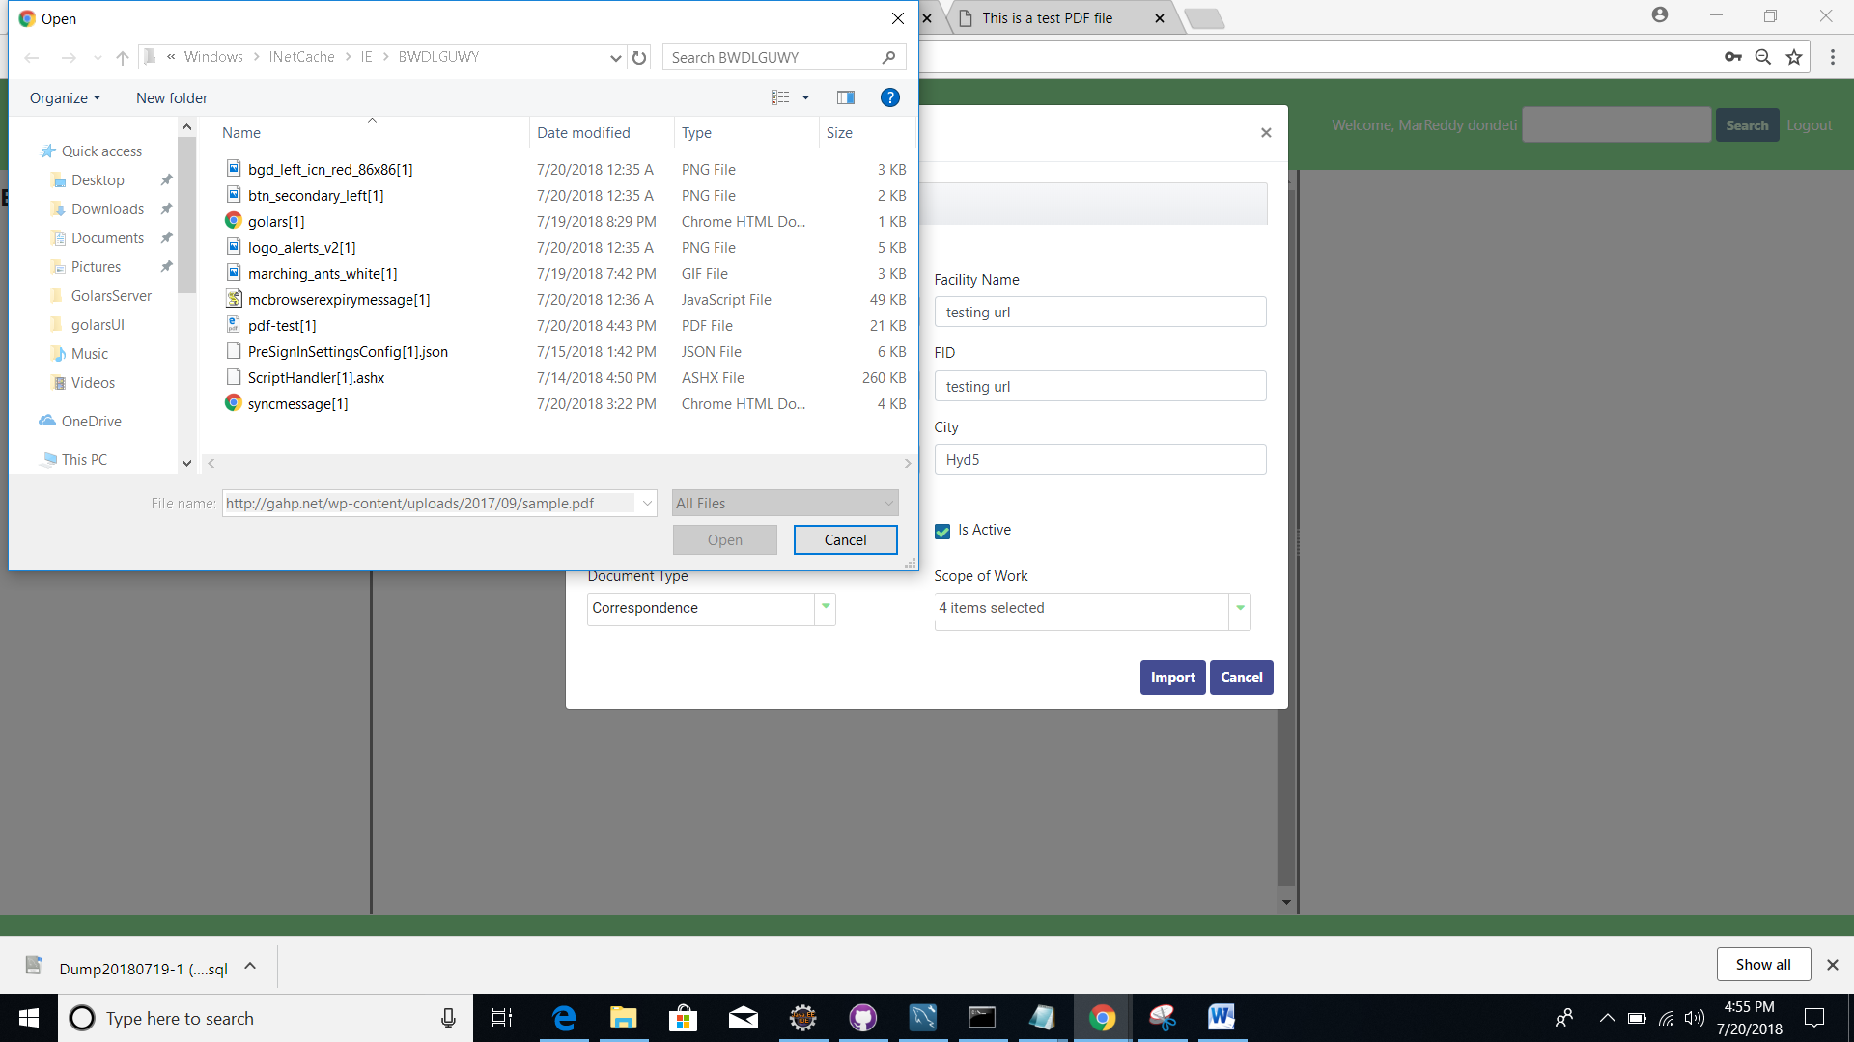

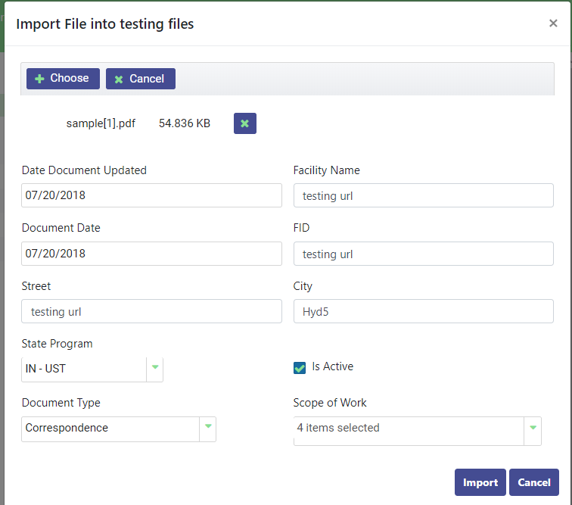

Imported Data will be stored in the Data Base.

**Properties Page:**

Right side panel will navigate to properties section.

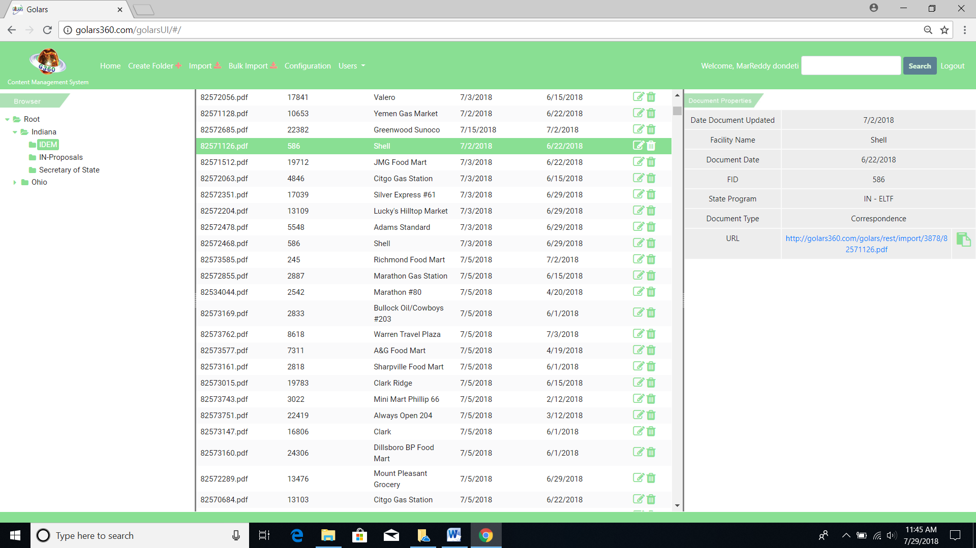

* Properties would display respective documents selection,
* If user selects Folder from navigation section, inside that folder on middle panel document’s properties, while importing the files would display on the right side panel.
* Users can get/copy **url** link for the respective files (PDF/WORD documents) URL to navigate on web browsers without any restrictions or can directly open the file by clicking the **url** link on the section.
* 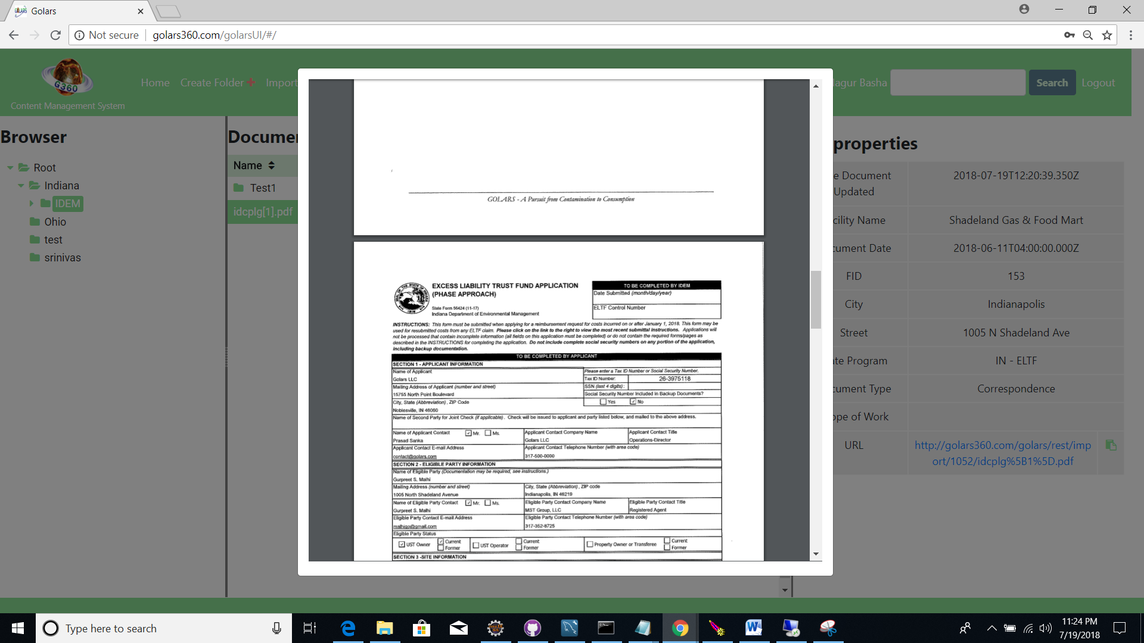

Bulk Imports

* Bulk imports allow the admin user to import the more than one file by selecting the XLS document, which should has a list all the existing file urls to import from.
* XLS should be in the format of proper structure to import all the files from the Bulk Imports.

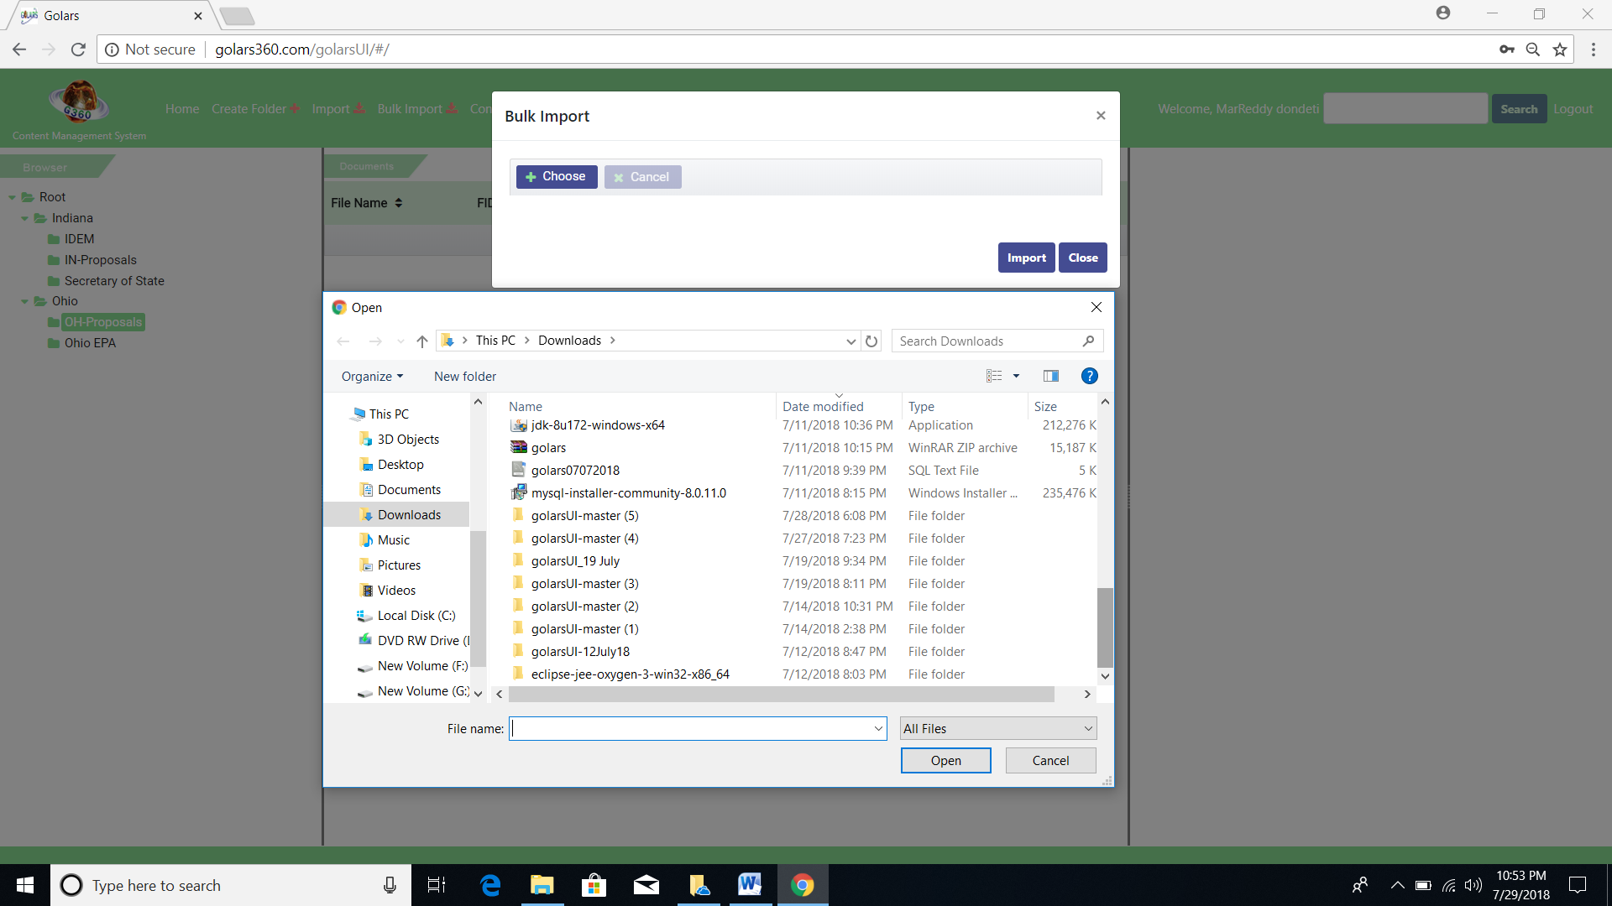

**Search function:**

* User can search documents by any name of the properties or any name of the document on search box.

